**LEARN INDIA VIDEO CONFERENCING APP**

**A Project Report**

Submitted in partial fulfillment of the

Requirements for the award of the Degree of

**BACHELOR OF SCIENCE (INFORMATION TECHNOLOGY)**

**By**

Memon Uzma Haroon & Jaiswal Nikhil Fulchand

**Under the esteemed guidance of**

Mrs. Swati Mandavkar



**DEPARTMENT OF INFORMATION TECHNOLOGY**

**SIDDHARTH COLLEGE OF COMMERCE & ECONOMICS**

***(Affiliated to University of Mumbai)***

**MUMBAI 400001**

**MAHARASHTRA**

**2022-2023**

**PROFORMA FOR THE APPROVAL PROJECT PROPOSAL**

***(Note:* *All entries of the proforma of approval should be filled up with appropriate and complete information. Incomplete proforma of approval in any respect will be summarily rejected.)***

PNR **No.: ……………………** Roll no**: ___________**

PNR **No.: ……………………** Roll no**: ___________**

1. Name of the Student

_____________________________________________________________

1. Title of the Project

_______________________________________________________________

1. Name of the Guide

_______________________________________________________________

1. Teaching experience of the Guide ___________________________________

1. Is this your first submission? Yes  No 

Signature of the Student Signature of the Guide

Date: ………………… Date: …………………….

# Abstract

Learn India Video Conferencing App is a virtual communication platform that enables users to participate in real-time video conferences with participants from all over World.

Learn India Video Conferencing App typically allow users to connect with other participants in different locations using video, audio, and messaging features.

One of the more important focuses of this project is to spread technology, information, and knowledge without any geographical limitation and without wasting time.

We have developed a Learn India Video Conferencing Application Based on based on Android Platform.

In this way, we can share and display our knowledge to other users using screen sharing.

Learn India Video conferencing apps typically use advanced video and audio to transmit data over the internet.

Learn India Video conferencing apps offer a range of features and tools designed to improve collaboration, productivity, and user experience.

# ACKNOWLEDGEMENT

The successful completion of the **"LEARN INDIA VIDEO CONFERENCING APP "** project would not have been possible without the guidance and assistance of many individuals, and I feel privileged to have had their support throughout the process.

I would like to express my sincere gratitude **to Dr. U. M. Maske, our Principal, the B.Sc. (I.T.)**

I would like to thanks **Coordinator Chhaya Pawaskar Ma’am** for their constant support throughout the Project Lifespan.

I would also like to express my sincere gratitude towards our **Project Guidance Mrs. Swati Mandavkar** whose guidance and instruction made our project successful**.**

Their constant encouragement, support, and guidance were instrumental in our success.

I am also grateful to my parents for their unwavering support throughout this project.

Furthermore, I would like to thank the college management and staff members for their cooperation, support, and for providing us with the necessary facilities to complete the project.

**Table of Contents**

Chapter 1: Introduction …………………..……………………………….........7

1.1 Background…………………………………………………………..7

* 1. Objective……………………………………………………………..7
  2. Purpose, Scope and Applicability…………………………………....8

1.3.1 Purpose…………………………..…...……………………..8

1.3.2 Scope...…………………………..………………………….8

1.3.3 Applicability……...………………..……………….……….8

* 1. Achievement…………………………………………………………8
  2. Organization & Report………………………………………………9

Chapter 2: System Analysis…………………………………………………...10

2.1 Existing System…………………………………………………….10

2.2 Proposed System……………………………………………………10

2.3 Requirement Analysis………………………………………………10

2.4 Hardware Requirement……………………………………………...11

2.5 Software Requirement………………………………………………11

2.6 Justification of selection of Technology…………………………….12

Chapter 3 System Design…................................................................................14

3.1 Module Division ................................................................................14

3.2 Data Dictionary ..................................................................................15

3.3 ER Diagram .......................................................................................16

3.4 Data Flow Diagram (level 0) .............................................................17

3.5 Sequence Diagram……......................................................................18

3.6 Activity Diagrams...............................................................................20

3.7 Use Case Diagram...............................................................................22

3.8 Deployment Diagrams.......................................................................23

3.9 Component Diagram..........................................................................24

Chapter 4 Implementation and Testing ..............................................................25

4.1 User Interface ....................................................................................25

4.2 Data Design .......................................................................................36

4.3 Security Issue .....................................................................................36

4.4 Testing Approach ...............................................................................36

4.4.1 Unit Testing………………………………………………...36

4.4.2 Integration Testing………………………………………….41

4.5 Implementation and Approach………………………………………42

Chapter 5 Results and Discussion ......................................................................43

5.1 Test reports .........................................................................................43

5.2 Discussion…………………………………………………………...43

5.3 User documentation ...........................................................................44

Chapter 6 Conclusion and Future work..............................................................54

6.1 Conclusion .........................................................................................54

6.2 Signification of the System................................................................55

6.3 Limitations of the System ..................................................................55

6.4 Future Scope………………………………………………………...56

Chapter 7 References…………………………………………………………..57

# CHAPTER 1: INTRODUCTION

## INTRODUCTION:

**LEARN INDIA VIDEO CONFERENCING APPLICATION** is high quality online video conferencing provides an environment that will feel like you are actually sitting down across from other participants in the same room and gives you that face-to-face contact needed to build trust and relationships. In the current scenario, where everything has gone online and people are working from home, and also students are learning via online classes conducted by the institutes, faculties with the help of this **VIDEO CONFERENCING PLATFORM**. **VIDEO CONFERENCING** has recently become **increasingly popular** and disperse in the wake of faster and cheaper internet connections and better technologies.

## BACKGROUND:

In Today Era, Privacy is most important thing for the users while they use some services. During Pandemic Some Video Conferencing apps got popular and get user handy. Some Video Conferencing apps that are used on regular bases are Zoom, Google Meet, WebEx Cisco, etc. But one cannot trust the privacy and data collection of user that is collected while using their services. This collection of data might not be allowed by the user. If User Deny some permission can broke the apps proper functioning. So, User has to allow some irrelevant permission sometimes to use their services.

## OBJECTIVES:

* + 1. Sharing documents through our **LEARN INDIA VIDEO CONFERENCING APP.**

ii)Display information while on Screen-Sharing.

iii)Provides scheduling sessions such as 60 minutes, i.e., 1 hour.

iv) Provide scheduling meetings for the users according to their needs such as students, office meetings, etc.

v) Only the admin has all the access.

vi) An admin can give an access to share User’s the stuff in the middle of the ongoing conference so that the User ’s can share the stuff in the meeting.

## PURPOSE, SCOPE And APPLICABILITY:

* + 1. **PURPOSE:**
    2. The main purpose for our **LEARN INDIA VIDEO CONFERENCING APP** it will reduce travel costs.
    3. **LEARN INDIA VIDEO CONFERENCING APP** can be used for team meetings, webinars, product demos, job interviews, and more.
    4. The main purpose of **LEARN INDIA VIDEO CONFERENCING APP** is to help people to connect, regardless of where they're staying.
    5. The main purpose of video conferencing is to enable face-to-face communication between two or more people in different locations.
    6. It is a popular alternative to phone conferencing for businesses and provides individual users with an inexpensive means of communication with distant friends and family.
    7. **SCOPE:**

1. More productive use of time and significant travel cost saving.
2. A conference session can be saved for future reference.

iii) **Example:** Class notes can be saved and distributed via the network for reference by student.

1. Facilitating short notice meetings between individuals in different locations.
2. The decisions can be made more quickly.
3. It is Simplify Management and Usability is More.
   * 1. **APPLICABILITY:**
        + It can be used for one to one personal or forum discussion.
        + It can be used in Education Organization for conducting lectures.
        + It can be used to conduct Business Meeting, Planning Strategies without any geographical limitation.
        + It can be used to present online presentation or to do Collaborative work.

## ACHIEVEMENTS:

1. In this Project we get the knowledge about how to work on an **Android Platform**.
2. This Project give us the knowledge about the **Firebase** what do in the database.
3. We have achieved how to manage the time in this project.
4. We have learned different Programming Languages like Java, Xml.

## ORGANISATION AND REPORT:

**This project consists of four (7) chapters.**

* + 1. **Chapter 1** is the introduction to the project. The background, objectives, purpose, scope, applicability and achievements of the project are explained in detail in this chapter.
    2. **Chapter 2** is Survey of Technologies which includes system analysis and existing system and Without This System How Present Work Is Going and Disadvantages of Present Time Without This System. All the relevant journal, thesis and books taken from those researches will be discussed in detail.
    3. **Chapter 3** is requirements and analysis; this chapter reveals the problem definition, requirements specification and planning and scheduling, software and hardware requirements and conceptual models. And besides this, it will also discuss about the process flow in detail of this research.
    4. **Chapter 4** is system design it consists of the Gantt chart and the processing and working of the development, it has data structures, algorithm design and security issues and test case design.
    5. **Chapter 5** is implementation and testing. This chapter documenting all the process that involved in developing this system and the testing made the system.
    6. **Chapter 6** is result and discussion it means the result or the output we get from the project and the discussion that is can be executed in the real time.
    7. **Chapter 7** is the conclusion and future scope it concludes and come out with a summary about the developed project?

# CHAPTER 2: System Analysis

## Existing System:

1. In **Today’s World Video Conferencing** scenario is one of the most popular and widely use in the world.
2. It **does not** have any **geographical limitation**.
3. **Zoom Meeting (Zoom Cloud), Google Meet, Microsoft, WebEx, Cisco etc**, and many more video conferencing application is existing today.
4. It gives, user more feature for use their application but not in all view.
5. **Zoom Meeting application** have average **300 million** users **per day of meeting.**
6. Google meet have **4 billion** users account i.e., about **52%** of the entire world population but a mole is Google meet supports only up to **100 participants for an unlimited duration.**
7. **Zoom Meeting** supports up to **100 participants** for **40 minutes (for free trail).**
8. **Skype** gives limitation up to **50 participants** for an **unlimited duration**.

## 2.2 Proposed System:

* + 1. In our **LEARN INDIA VIDEO CONFERENCING APP** we can easily share documents i.e., pdf.
    2. In **Zoom Android Operating System** we cannot share documents it is available in paid version and another

**Operating System (OS) i.e., Windows (Microsoft) and in iOS**.

* + 1. The Time limit for **LEARN INDIA VIDEO CONFERENCING APP** is 60 minutes i.e., 1 hour.
    2. The main purpose for doing this as we have seen in many videos conference app, we have to pay for it, for the extra features.
    3. We have **disabled the screen-shot feature** for the users.
    4. It will help to make the users financial condition stable/maintain/balanced.

## 2.3 Requirement Analysis:

1. In requirement analysis we will see all type of success and all type of failure when we create any particular software.
2. There will be the requirement of stake holders and the need of end user to use our software.
3. All requirements are defined in detail and work as a system specification.
4. There are two type of requirement hardware requirement and software requirement.

## 2.4 Hardware Requirements:

### Camera:

* + A camera to capture images and convert them into an electrical signal. The location of the camera must be ideal to allow for realistic eye contact. Also, the good quality and functionality of the cameras should be able to provide a sharper, more colorful image, with less visual noise.

### Microphone:

* + Microphones used in video conferencing are usually very sensitive and should be placed away from types of equipment like projectors which can produce some background noise.

### Video Conferencing Unit:

* + The video conferencing unit usually referred as the codec (Coder/Decoder) accepts the vision and sound signals (video and audio) and process them into a suitable format for transmission through the network to the remote site.
  + To receive information the Decoder does the reverse: it accepts the digital signals from the remote site over the network and decodes or converts these into video and audio.
  + Finally, this video and audio are fed to a display unit and speaker to display the pictures and reproduce the sound from the remote site respectively.

### Audio System

* + A good audio system is ideal for video conferencing.
  + In some instances, Mobile Speakers are used but, in most instances, (i.e., classroom, boardrooms, etc.), a good audio system with mixer, amplifier and speakers might be required.

## 2.5 Software Requirements:

### Android Studio:

#### Android Studio is an Integrated Development Environment (IDE) that is used to build an Android App.

* + It is an **Open Source** in Android Studio.
  + In Android studio, we are using the **Java Language** to build our **Programming Languages.**
  + Android is thought of as a **Mobile Operating System.**
  + Android Studio provides a rich application framework that allows us to build innovative **apps**

and **games** for mobile devices in a **Java language environment.**

### Jitsi:

* + Jitsi is an **open-source platform** and does not require account creation.

#### Offers browser, desktop, and mobile based apps.

* + Later the team added Jitsi Meet, a full video conferencing application that includes **web, Android, and iOS clients.**
  + Jitsi Meet is a **fully encrypted**, it has **100% open-source video conferencing** solution that you can use all day, every day, for free of cost.

### User’s Interface Requirement:

* + Minimum **Android Version 7** or **higher Version**.
  + Minimum **Space requirement** 500 MB for **Smooth Performance.**
  + Phone must have **worked Camera**, **Microphone**, **Speaker.**
  + There should be having proper **Internet Connection**.

## 2.6 Justification of selection of Technology:

* We have seen many Programming Languages like **Java, Flutter, XML, Node.js, Apache Cordova, Ionic 5, Firebase, Django, and Laravel.**
* In our **LEARN INDIA VIDEO CONFERENCING APP**, we are using **Java, and XML** for our **Front-end.**
* For **Back-end** we have selected **Firebase.**
* We have chosen **Java** over **Kotlin** in our **Front-end.**

| **Java** | **Kotlin** |
| --- | --- |
| * Java is limited to **object-oriented programming.** | * Kotlin combines features of both **object- oriented and functional programming.** |
| * **Null variable** or **objects** are part of Java language | * There are **no null variables** or **objects** in Kotlin |
| * Java supports implicit conversions. | * Kotlin doesn’t offer implicit conversions |
| * Java uses **static members.** | * Kotlin doesn’t support **static members.** |
| * **Wild-card** is available in Java. | * Kotlin **doesn’t** have any **wild- card**   types. |

* We have also Chosen **XML** for our **Front-end.**
* XML stands for **Extensible Markup Language.**
* XML is a Markup Language much like HTML used to describe data.
* XML tags is **not predefined** in XML.
* XML as itself is well readable both by **human** and **machine.**
* We have chosen **Firebase** over **SQLite** in our **Back-end.**

| **Firebase** | **SQLite** |
| --- | --- |
| * Firebase is a **close source Platform.** | * SQLite an **open-source platform.** |
| * Firebase offers **real-time databases.** | * SQLite is an in-process **embedded relational database management system (RDBMS).** |
| * Suitable for both **iOS** and **Android applications.** | * More suitable for **Android applications.** |
| * Cloud Fire store and Realtime Database are NoSQL document and cloud databases. | * SQLite is a Structured Query Language (SQL) database. |

# Chapter 3. System Design

## 3 System Design:

* In the First step of Development Phase for any software is created. The design we our making for our **Learn India video conferencing app.**
* To understand the problem before you begin to create any model.
* To keep it as simple as possible to address today’s drawback while creating the project.

## Module Division:

This module division helps us to divide the overall drawback into units and develop module individually. In this topic we have detail of the project module and functionally of the module using Figures.

### Login Page.

* + A **login page** is an **entry page** in an **application** that requires user **identification** and

#### authentication.

* + In a **login page** by entering a **email and password combination is used**.

### Home Page.

* + A **Home Page is generally the primary application page** which a visitor navigating it.
  + A Home Page is the **default or front page of a site**.

### Meeting:

#### Meeting ID:

* + A meeting ID can be had at least **10 or 11-digit number** to join a meeting.

#### The Meeting room is a virtual meeting room that is permanently reserved for you

that you can access to your meeting id.

#### Meeting History:

* + **Meeting History** in order to allow **users** to access past **meetings** with **Time** and **Date** during the **meeting.**
  + **Meeting History helps** users if **mistakenly** they leave the meeting due to **Network** **Issues** in **Meeting** **History** the **History** would be **provided** to the **user.**
* **Document Sharing:**
  + Document sharing allows a number of people to share the documents to each other.
  + Sharing document is a necessary part for any Business or Educational Purposed.

#### Screen-Sharing:

* + Screen sharing, where one person shares their computer’s desktop or a single application with one or more people, generally serves one of three purposes:
  + Quick collaboration and meetings between co- workers.
  + Client communications, such as sharing a presentation or other application.
  + Technical support for IT staffers (or any tech-savvy individual) looking to solve a remote worker’s computer issue.

#### Screen-Shot Disabling :

* + A screenshot capturing restriction may have been put in place by an institution or the phone manufacturer.
  + If you're using an Android device supplied by work or school, it may have a device- or account-based restriction to prevent screenshot capturing for company security policy reasons.

## Data Dictionary:

### Firebase:

* + - * Firebase provides detailed documentation and cross- platform to help you **build on Android, IOS.**
      * And **manage** to **store** a **Data**

### Credentials:

* + - * **User collection:** It consists of users name and password.
      * **Name:** User name should be unique.
      * **Password:** For authorizing the user.
      * **Document Collection:** The document collection is a consist of class id and document name.
      * **Class id:** Unique key to identify each group.
      * **Document file:** Various types of documents can be shared i.e., image file pdf, docs, ppt.

## Entity Relationship - (ER) Diagram:

* ER model stands for an **Entity-Relationship Model.**
* This model is used to define the **data elements** and **relationship** for a **specified system.**

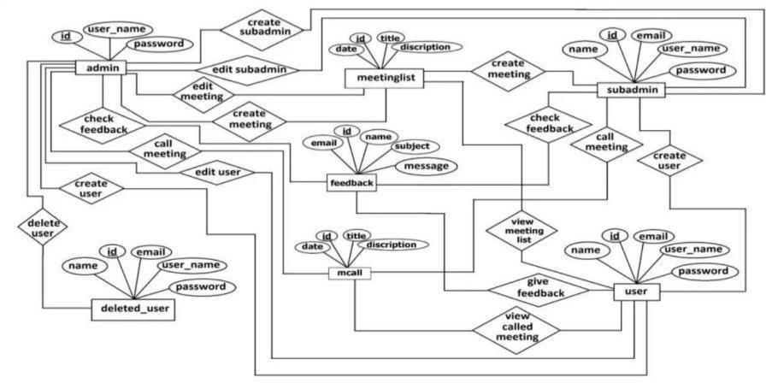

## Data Flow Diagram (DFD):

* It shows the flow of data between various functions of system and specifies how the **current system** is **implemented.**
* **Data Flow Diagram (DFD)** is easy to understand and quite effective when the **required design** is not clear and the user wants a **notational language** for **communication.**

### Level – 0:

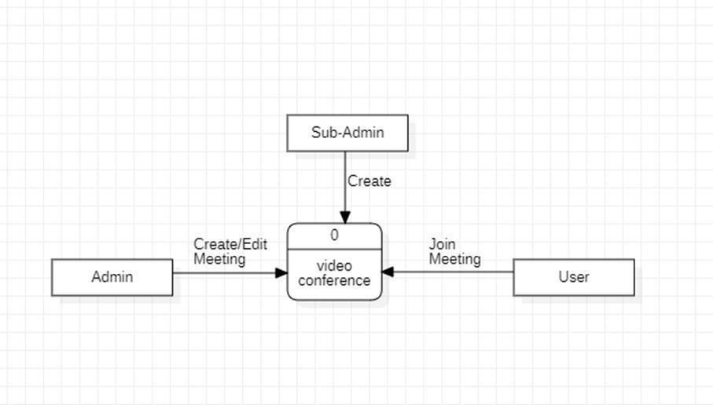

**Level – 1:**

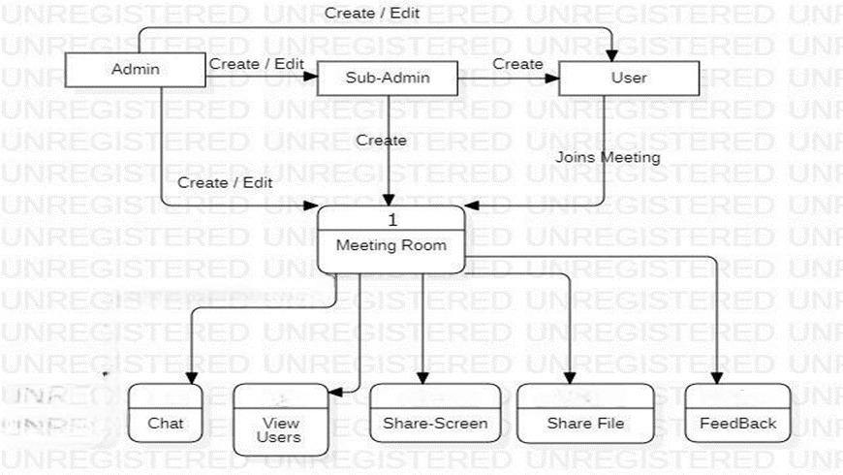

## Sequence Diagram (SD):

* + - A Sequence Diagram is **a Unified Modelling Language (UML) diagram** that illustrates the **sequence of messages** between **objects** in an interaction.
    - The Sequence Diagram is a good diagram to use **to document a system's requirements and to flush out a system's design**.

### Sequence Diagram of Admin.

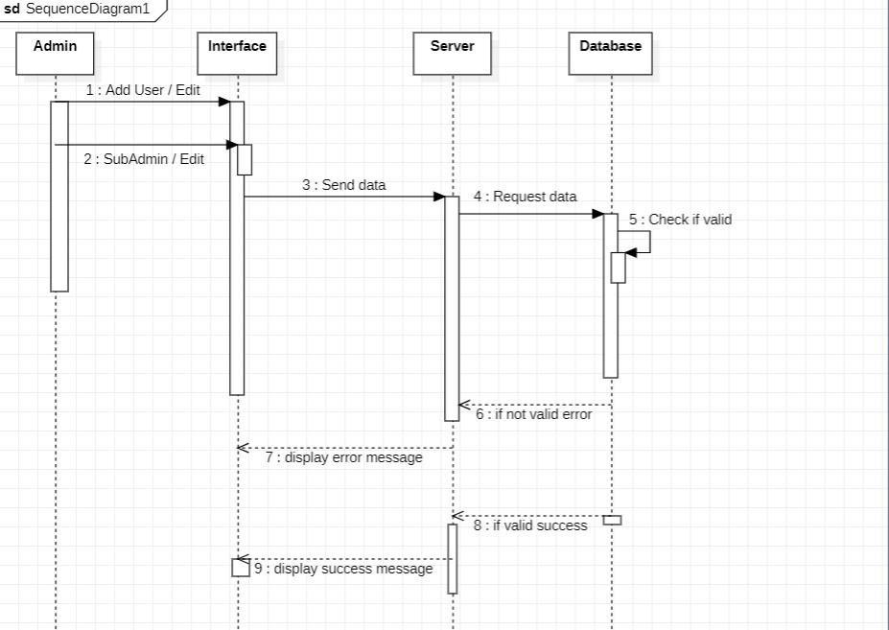

* + - **Sequence Diagram of Join Meeting.**

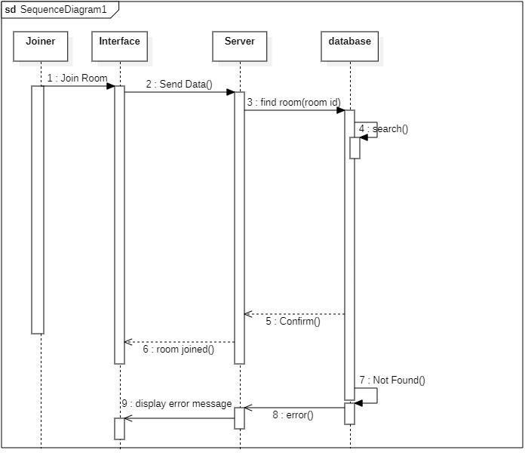

## Activity Diagram:

* + - **Activity diagram** is another **important diagram** in **UML** to describe the **dynamic aspects**

of the **system.**

* + - **Activity diagram** is basically a **flowchart** to represent the flow from **one activity** to **another activity.**

### Activity Diagram for Admin.

* + - **Activity Diagram for Join Meeting.**

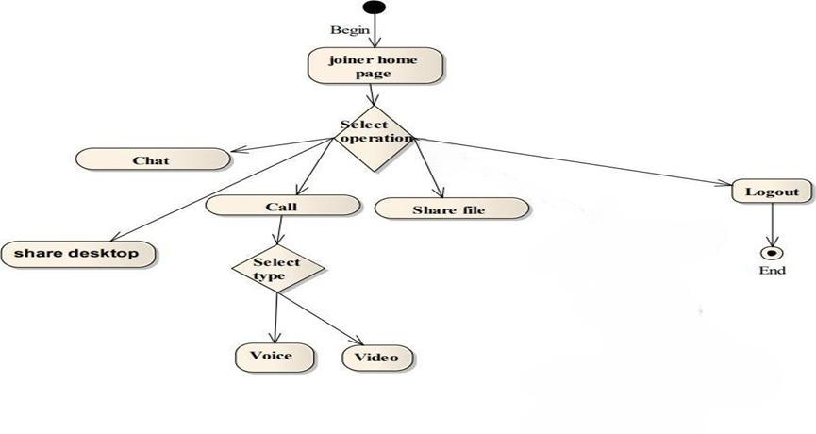

## Use Case Diagram:

* + - **Use Case Diagram** are drawn to capture the **functional requirements** of a system.
    - **Use Case Diagram** consists of **Actors**, **use cases** and their **relationships**.

### Use Case Diagram of Login Page.

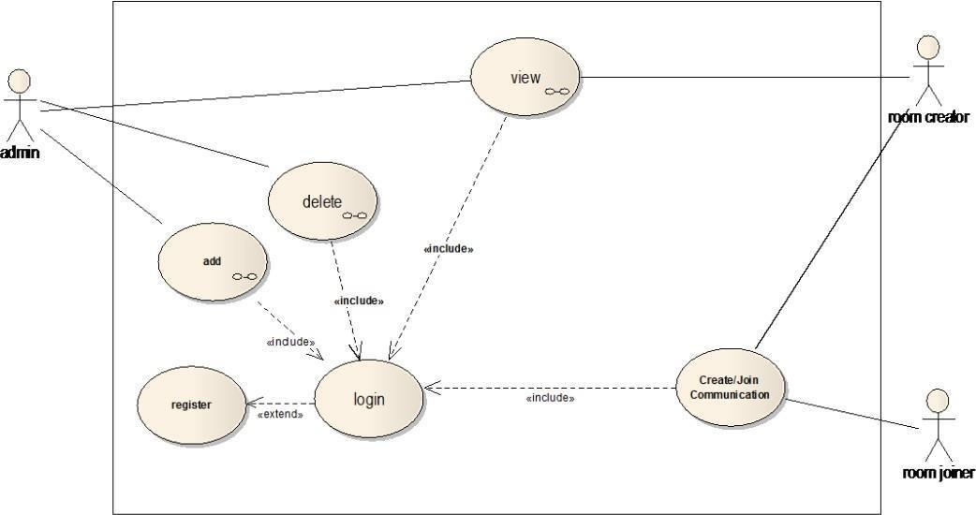

* + - **Use Case Diagram of Home Page.**

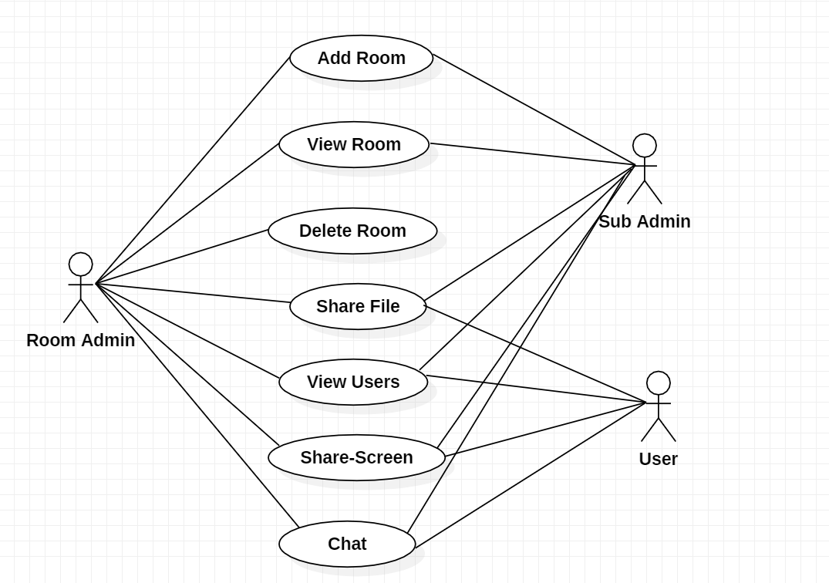

## Deployment Diagram:

* + - The **Deployment Diagram** is the **Unified Modelling Languages** models is the **physical deployment** of **Artifacts** on **nodes.**
    - The main purpose of the **Deployment Diagram** is to represent how **software** is installed on

**the hardware component.**

* + - **Deployment Diagram of Meeting Room :**

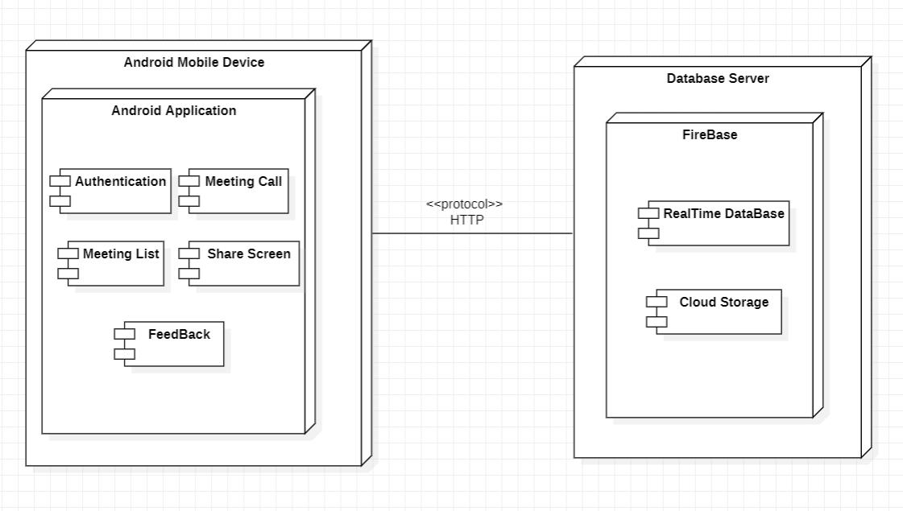

## Component Diagram:

* + - The **Component Diagram** breaks down the actual system under **development** into various

**high levels** of functionality.

* + - A component diagram, also known as a **Unified Modelling Languages component diagram**, **describes** the **organization and wiring** of the **physical components in a system**.
    - **Component Diagram of Meeting Room :**

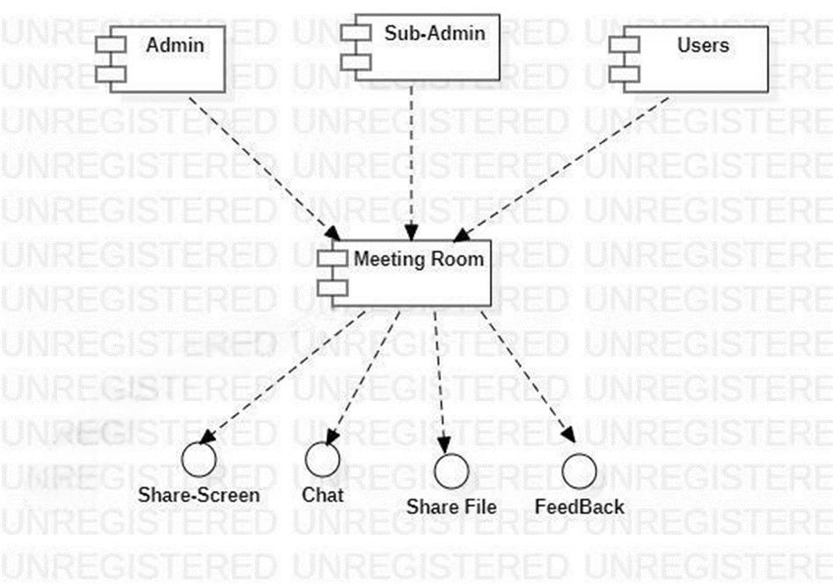

# Chapter 4. Implementation And Testing

## User Interface:

### Learn India Icon:

### 

### Description: This is the icon of the Learn India App.

### Splash-Screen:

* **Description:** **This is the 1st Activity which is loaded when User Open the Application.**
  + - **Login Page:**

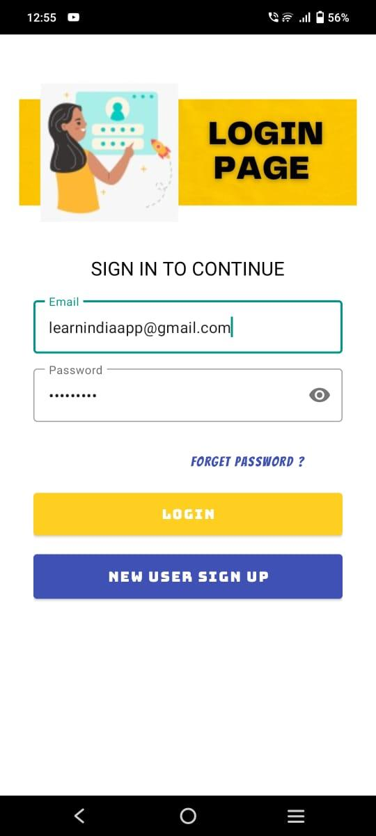

* **Description:** **This the 2nd Activity where the user has to login with his/her EMAIL And Correct PASSWORD.**
* **Forget Password:**
* **Description:** **This Is the 3rdActivity where if User Forget his/her password they just need to put Email a link will send to the email over there you can set your password to login the app.**
  + - **Register Page:**

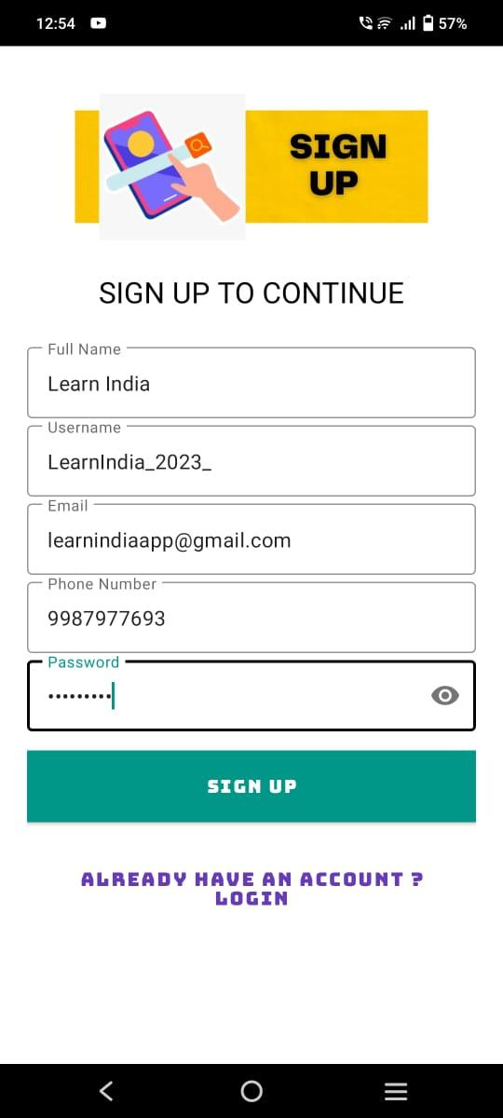

* **Description: This is the Fourth Activity users have to provide valid credentials to create an account for using the application.**

### Verification Page For OTP:

* **Description: Verifying tab will open for a few second to check whether the User is not the Robot.** 
  + - **Otp Message For Verification:**



* **Description: An OTP will be generated to your Phone Number for the Security Purpose.**

### OTP VERIFY:

* **Description: This is the 5th Activity after the User has entered their REGISTER DETAIL, the service sends a unique OTP code to the Number. The user then enters the OTP code on the verification page to confirm their identity.**
* **Verification For E-Mail:**

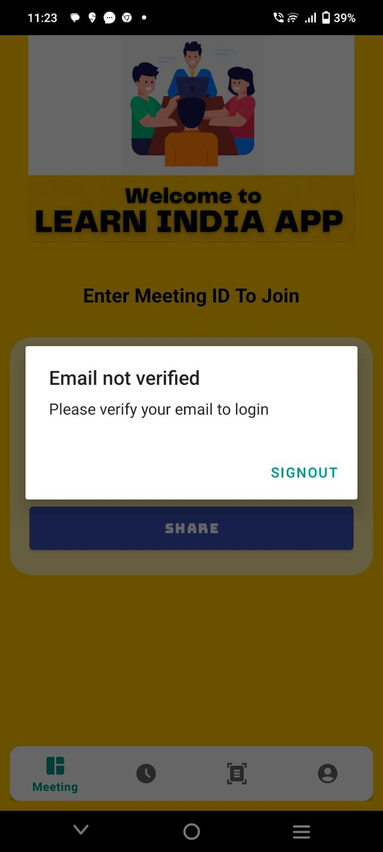

* **Description:There will be a pop-up message would be coming After verify the email then only you will enter the Meeting Page.**

### E-Mail Verification On G-Mail:

* **Description: There will be a pop-up message would be coming After verify the email then only you will enter the Meeting Page.**
* **Meeting I’d For Joining Room:**

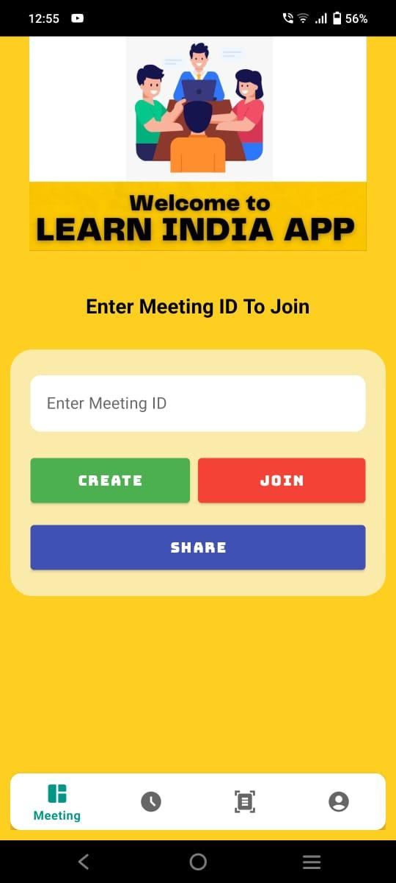

* **Description: This is the 6th Activity where to join the Meeting Room for joining the meeting.**

### Meeting Room:

### 

* **Description: This is the Meeting Room after putting the Meeting ID.** 
  + - **Meeting Chat Room:**



* **Description: This is where the User can chat with the Participant who have Join in the Meeting Room.**

### Meeting Polls Room:

* **Description: This is the Polls where the User can ask question with the Participant who have Join in the Meeting Room.**
* **Meeting Participants Room:**
* **Description: This is the Meeting Participants where user can view how many people have join the Meeting Room.**

### Meeting Settings Room:



* **Description: This is the Meeting Setting where User can see and use all requirement setting.**
* **Meeting History:**

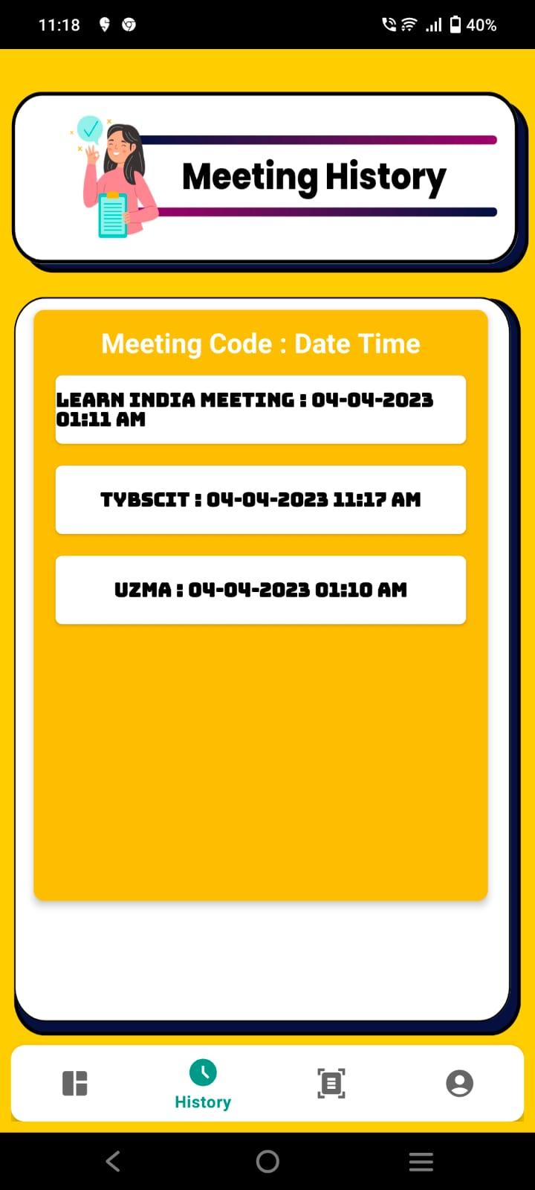

* **Description: This is the 7th Activity Meeting History where User can see the History when ever the user will join in the Meeting Room user can go to Meeting History Tab to view the Meeting History.**

### Document Share:

### 

* **Description: This is the 8th Activity of PDF Sharing where user double click the and upload the file. Database Stores PDF Title and URL of the File Uploaded in Firebase Storage.**

### Document Retrieve:

### 

* **Description:**  **This is the 9th Activity of PDF Retrieve where users put their user’s name to Retrieve or View someone's PDF through their Username.**

### USER PROFILE:

### 

* **Description: This is the 10th Activity Where User Can View the Profile and Edit the Full Name and the Username the user can view all details in this tab.**

### USER PROFILE UPDATE:

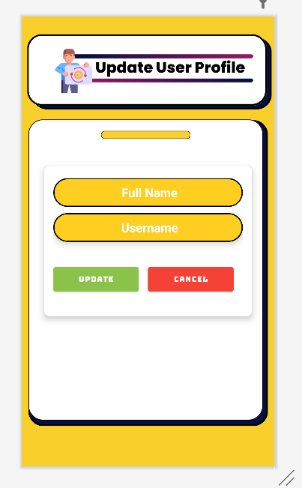

* **Description: This is the 11th Activity Where User can UPDATE the Profile and Edit the Full Name and the Use.**

### LATEST APP UPDATE:

### 

* **Description: This is the 12th Activity Where User have to Update the App if any changing has happened in the App. To keep user upgrade of the App.**

## Data Design:

* When designing the data model of **Learn India video conferencing App** we have using the **Firebase**

and the developers should focus on the following things: -

#### Data security.

* + **Scalability.**

#### Real-time synchronization.

* By following best practices and utilizing the features of **Firebase**, Developers can build secure and reliable video conferencing apps for Android projects.
* Before designing the **data model**, it's **important** to determine the **structure** of the **data** that will be

**stored** in the **database.**

* For example: The **data structure** may include information about users are: -

#### Meeting Rooms.

* + **User’s Profile.**
  + **Meeting History.**
  1. **Security Issues:**

.

* The data which is travelling from android device to the **Firebase Database** is not **encrypted**.
* Because **Android** is a free and **open-source** operating system, an **unauthorized or unorganized person** can see all our activities.
* Some **companies** use the user’s data unfairly by **selling** it to **third-party apps.**
* All the **data are stored** at a centralized database, so if that **crashes, application streaming and uploading** functionality gets **broken.**
* As this application is created from a learner’s perspective it does not follow **any robust design pattern** so breaking inside the application is possible.

## Testing Approach:

* + - A test approach is the **test strategy** implementation of a project, defines how testing would be carried out.
    - There are two type of Testing approach:

#### Proactive:

* An approach in which the test design process is initiated as early as possible in order to find and fix the defects before the build is created.

#### Reactive:

* An approach in which the testing is not started until after design and coding are completed.

### 4.4.1 Unit Testing:

* + - * **UNIT TESTING** is a type of software testing where **individual units** or **components** of a software are tested.
      * Unit Testing is done **during the development (coding phase)** of an application by the

**Developers.**

### Test Case Design for Login Page:

| **Test Case Id** | **Test Case Name** | **Test Case Description** | **Test Input** | **Expected Output** | **Actual Output** | **Test Case Status- (P/F)** |
| --- | --- | --- | --- | --- | --- | --- |
| 1 | Email id | Only Registered Email are Allowed | nick@ gmail. com | Login Successful | Login Successful | Pass |
|  |  |  | nick@ab c.com | Invalid Email | Invalid Email | Fail |
| 2 | Password | To verify Entered password is corrected | 1234567 | Login Successful | Login Successful | Pass |
|  |  |  | 012345 | Incorrected password | Incorrected password | Fail |
| 3 | Password | Password length should be more than 7 | 1234567 | Login Successful | Login Successful | Pass |
|  |  |  | 1234 | Invalid password | Invalid password | Fail |
| 4 | Login | To verify email and password should be not be blank | nick@ gmail. com 1234567 | Login Successful | Login Successful | Pass |
|  |  |  | Fields are empty | Please Enter your Email and Password | Please Enter your Email  and Password | Fail |

* **Test Case Design for Register Page:**

| **Test Case Id** | **Test Case Name** | **Test Case Description** | **Test Input** | **Expected Output** | **Actual Output** | **Test Case Status-**  **(P/F)** |
| --- | --- | --- | --- | --- | --- | --- |
| 1 | Full Name | Only valid Full Name are allowed | Nick Jaiswal | Register Successfully | Register Successfully | Pass |
|  |  |  | Nick Jaiswal@145$ | Invalid Full Name | Invalid Full Name | Fail |
| 2 | User Name | Only valid Username are allowed | Nick_01 | Register Successfully | Register Successfully | Pass |
|  |  |  | Nick 11 | Invalid Username | Invalid Username | Fail |
| 3 | Email | Only Email are Allowed | [nick@gmail.com](mailto:nick@gmail.com) | Register Successfully | Register Successfully | Pass |
|  |  |  | nick@ab c.com | Invalid Email | Invalid Email | Fail |
| 4 | Phone Number | Phone Number are allowed | 96325874123 | Register Successfully | Register Successfully | Pass |
|  |  |  | 96325874123658 | Invalid password | Invalid password | Fail |
| 5 | Password | Password length should be more than 7 | Nick12345 | Register Successfully | Register Successfully | Pass |
|  |  |  | 23427 | Invalid password | Invalid password | Fail |
| 6 | Register | To verify Username, Password, Confirm Password Should be not be left blank | Nick Jaiswal Nick1234  CP: Nick1234 | Register Successfully | Register Successfully | Pass |
|  |  |  | Fields are empty | Please Enter Username, Password, Confirm Password | Please Enter Username, Password, Confirm Password | Fail |

## Test Case Design for Meeting Joining Page:

| **Test Case Id** | **Test Case Name** | **Test Case Description** | **Test Input** | **Expected Output** | **Actual Output** | **Test Case Status**  **-(P/F)** |
| --- | --- | --- | --- | --- | --- | --- |
| 1 | Room ID | Enter your room id (Admin create id as: Uzma123) | Uzma123 | Room id Successfully | Room id Successfully | Pass |
|  |  |  | Uzzu | Invalid Room id | Invalid Room id | Fail |

## Test Case Design for Audio:

| **Test Case Id** | **Test Case Name** | **Test Case Description** | **Test Input** | **Expected Output** | **Actual Output** | **Test Case Status-**  **(P/F)** |
| --- | --- | --- | --- | --- | --- | --- |
| 1 | Audio | To verify audio is working properly or not | Audio ON | Audio done Successful | Audio done Successful | Pass |
|  |  |  | Audio OFF | Audio is not detected | Audio Not done Successful | Fail |

### Test Case Design for Video:

| **Test Case Id** | **Test Case Name** | **Test Case Description** | **Test Input** | **Expected Output** | **Actual Output** | **Test Case Status-**  **(P/F)** |
| --- | --- | --- | --- | --- | --- | --- |
| 1 | Video | To verify video is working  properly or not | Video ON | Video done Successful | Video done  Successful | Pass |
|  |  |  | Video OFF | Video is not detected | Video Not done Successful | Fail |

* **Test Case Design for Share Screen:**

| **Test Case Id** | **Test Case Name** | **Test Case Description** | **Test Input** | **Expected Output** | **Actual Output** | **Test Case Status-**  **(P/F)** |
| --- | --- | --- | --- | --- | --- | --- |
| 1 | Share- Screen | To verify is Share-Screen working properly or not | Video ON | Share-Screen done Successful | ShareScreen done Successful | Pass |
|  |  |  | Video OFF | Share-Screen is not detected | ShareScreen Not done Successful | Fail |

### Test Case Design for View the Participants:

| **Test Case Id** | **Test Case Name** | **Test Case Description** | **Test Input** | **Expected Output** | **Actual Output** | **Test Case Status- (P/F)** |
| --- | --- | --- | --- | --- | --- | --- |
| 1 | View the | To verify is | Uzzu | View the | View the | Pass |
|  | Participants | View the | Nick | Participants | Participants |  |
|  |  | Participants |  | done | done |  |
|  |  | working properly |  | Successful | Successful |  |
|  |  | or not |  |  |  |  |
|  |  |  | Not | View the | View the | Fail |
| putting | Participants | Participants |  |
| Your | is not | not done |  |
| Proper | detected | Successful |  |
| Username |  |  |  |

### Test Case Design for PDF Sharing:

| **Test Case Id** | **Test Case Name** | **Test Case Description** | **Test Input** | **Expected Output** | **Actual Output** | **Test Case**  **Status- (P/F)** |
| --- | --- | --- | --- | --- | --- | --- |
| 1 | PDF  Sharing | To verify PDF Sharing is working properly or not | SPM.pdf | PDF Sharing done Successful | PDF  Sharing done Successful | Pass |
|  |  |  | SPM | PDF Sharing is not detected | PDF  Sharing not done Successful | Fail |

### 4.4.2 Integration Testing:

* **INTEGRATION TESTING** is defined as a type of testing where **software modules** are

**integrated logically** and **tested** as a **group.**

* A **typical software** project consists of **multiple software modules**, **coded** by different programmers.
* **Integration Testing:**

| **Sr No.** | **Test Case Name** | **Type** | **Description** | **Pass /Fail (P/F)** |
| --- | --- | --- | --- | --- |
| 1 | Camera Detection | Detected | Camera detected | Pass |
|  |  |  | Camera not detected | Fail |
| 2 | Microphone | Detected | Microphone detected | Pass |
|  |  |  | Microphone not detected | Fail |
| 3 | Internet | Detected | Internet Detected | Pass |
|  |  |  | Internet not detected | Fail |

## 4.5 Implementation and Approach:

* In an android project, there is a **complexity to implementing** a Video Conferencing feature.
* However, depending on the specific requirements and our tools, it opens up several other approaches to us.
* Depending on the requirements of the specific tools, it can open up several other approaches to us.
* **Firebase Realtime Database and Firebase Cloud Messaging**, both of which can be used to build video conferencing functionality.

#### Camera and microphone access:

* + - You'll need to request permission from the **user to access** their device's camera and microphone, then use Camera to capture and encode the video and audio streams.

#### Network communication:

* + - To establish the video call connection, you'll need to use **Network to communicate** with the **other participant(s).**
  + **User interface:**
    - You'll need **to design and implement the user interface** for the video conferencing, including views for the local and remote video streams, buttons for muting and ending the call.

# Chapter 5. Results And Discussions

## 5.1 Test Report:

* In Our Project, **LEARN INDIA VIDEO CONFERENCING APP** we tested the **App's ability** to **Create and Join meetings, Screen-Sharing, Chat Functionality, and File Sharing through Firebase Storage.**
* During the **Testing Phase**, we **identified** and **fixed** **several issues** related to user experience, including the **App's responsiveness, clarity of audio and video, and the quality of file sharing.**
* We also performed rigorous **Security Testing** to **ensure** that the **App Protected** **user data and privacy.**
* The **Security Testing** included testing for **Vulnerabilities**, **Data Protection**, and **Access Control Mechanisms.**
* Based on the **Test Results**, we are confident that the **Video Conferencing App** meets the **requirements** of the **users and provides** a **seamless** and **secure** Video Conferencing experience.
* We have **Documented** all our **Test Cases** and their **Results** in the **Test Report**, along with any issues that were **identified** and their **Resolutions.**
* Our **Test Report** includes **Detailed Documentation** of the **Testing Process**, including the **Environment, Tools, Test Cases, and Results.**
* In **Conclusion**, we are **pleased to report** that our **Video Conferencing App** with **Firebase Authentication, Firebase Storage**, and **File Sharing** capabilities has passed all our **Tests** and is ready for **Deployment.**
* We **believe** that the **App** will provide an **Excellent** **User Experience** and **meet the needs of the users**, and **we look forward to seeing the App being used by our Users.**

## 5.2 Discussions:

# This Project is a Significant Achievement that provides Users with a Secure and feature-rich Video Conferencing Experience.

# The Integration of Firebase Authentication provides a Seamless and Secure User Authentication Process, while Firebase Storage ensures that Users can Share Files easily and securely.

# The App's features, such as the ability to Create and Join Meetings, Screen Sharing, Chat Functionality, and File Sharing through Firebase Storage, are all Essential Components of a Successful Video Conferencing Experience.

# The Security Feature to Disable Screenshots adds an extra layer of protection, ensuring that Users' Privacy is Protected and Sensitive Information is not Shared without Permission.

# During the Development Process, We Faced a lot of Challenges in Integrating the Firebase SDKs and Ensuring that the App was User-Friendly and Easy to Navigate.

# However, we overcame these Challenges and Created an App that Works Seamlessly and provides an Excellent User Experience.

# The Success of the App can be Evaluated based on Criteria such as Functionality, User Experience, Performance, and Security.

# Our Testing Process was thorough, and we identified and Fixed Several Issues related to User Experience and Security, which adds to the overall Quality of the App.

# Overall, Our LEARN INDIA VIDEO CONFERENCING APP with Firebase Authentication, Firebase Storage, and File-Sharing capabilities is a Success.

# It meets the needs of the Users, provides a Seamless and Secure Video Conferencing Experience, and has the potential to be a Valuable Tool for Individuals and Businesses alike.

# We plan to continue to improve and add new features to our App to meet the Evolving needs of our Users.

## 5.3 User Documentation:

1. **SIGN UP / LOGIN:**

* Open the **Learn India App** and Click on **New User Sign Up button.**

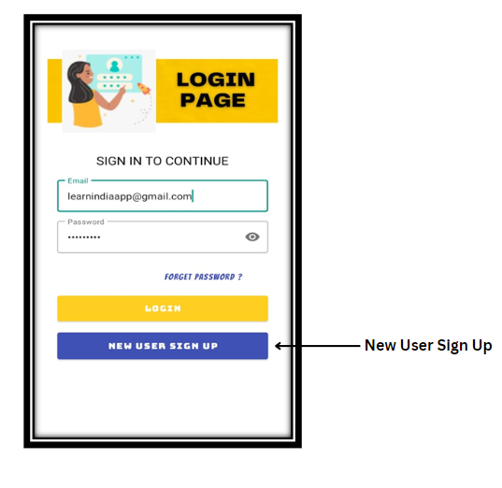

* Fill in all the **Detail** on the **Sign-up page.**

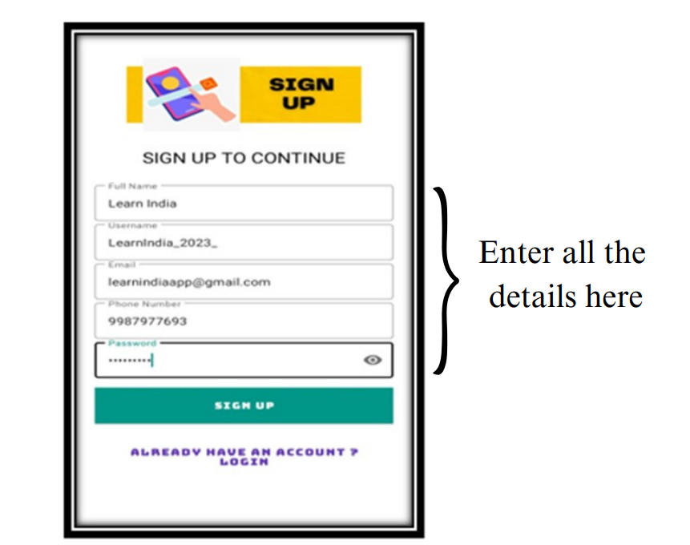

* And **OTP page** is **provided** for **Security purposes.**

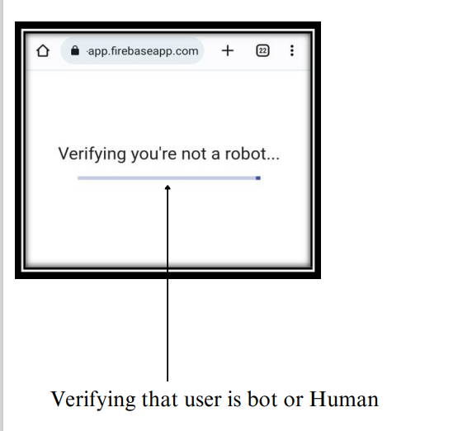

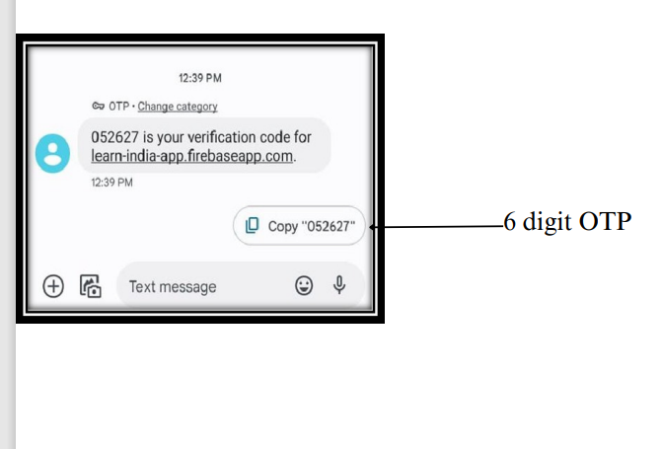

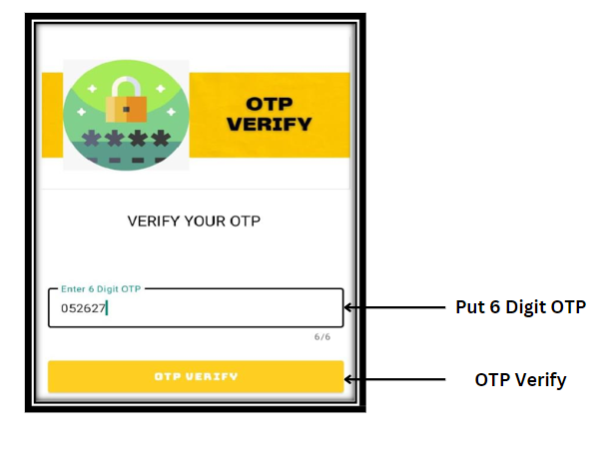

* **Login** with the same **Credentials** on the **Login** **page.**

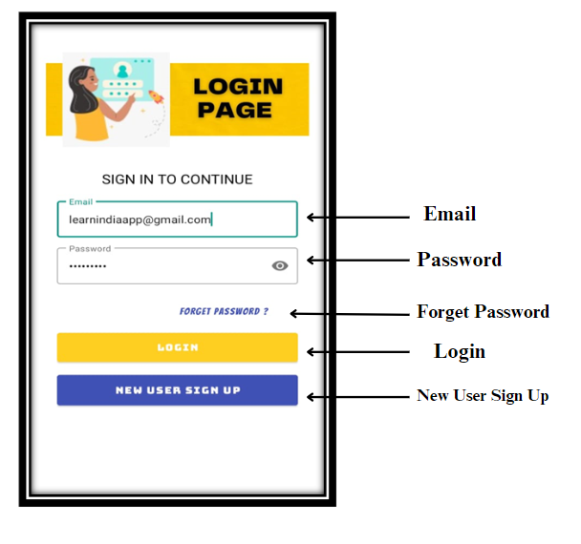

* **Forget** **page is provided if the User Forgets the password.**

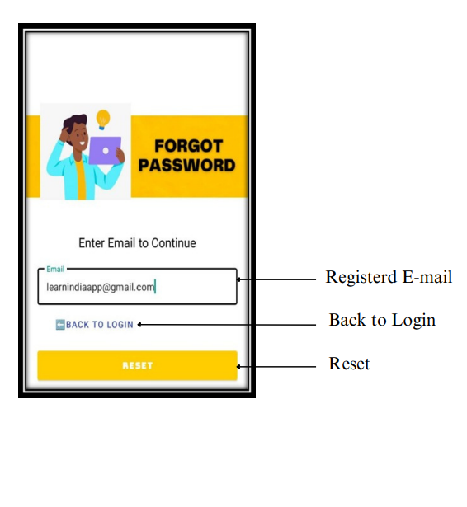

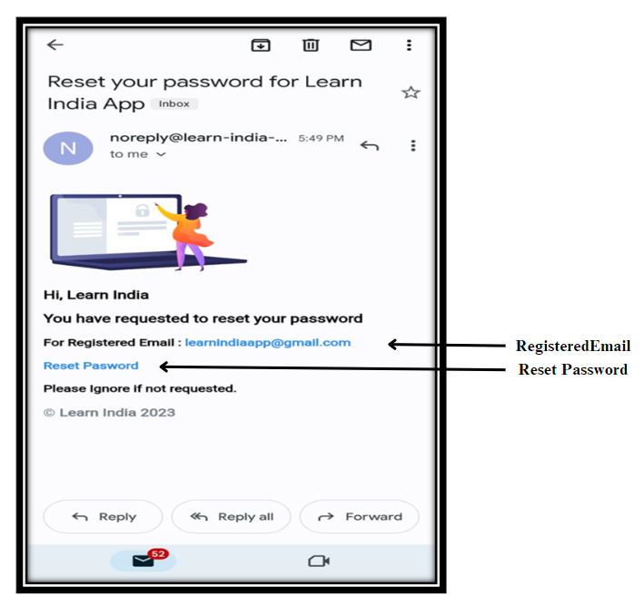

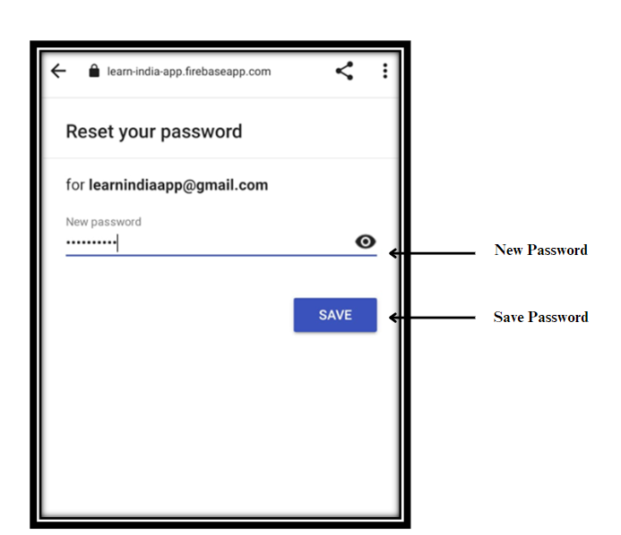

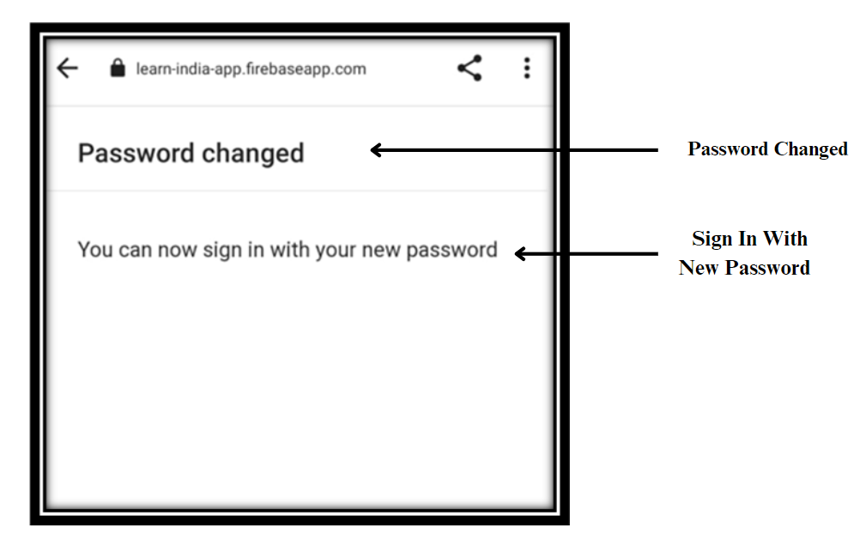

1. **MEETING FUNTIONS:**

* Click on the **Meeting icon** and **Enter the Meeting ID** to **Create/Join the Meeting.**

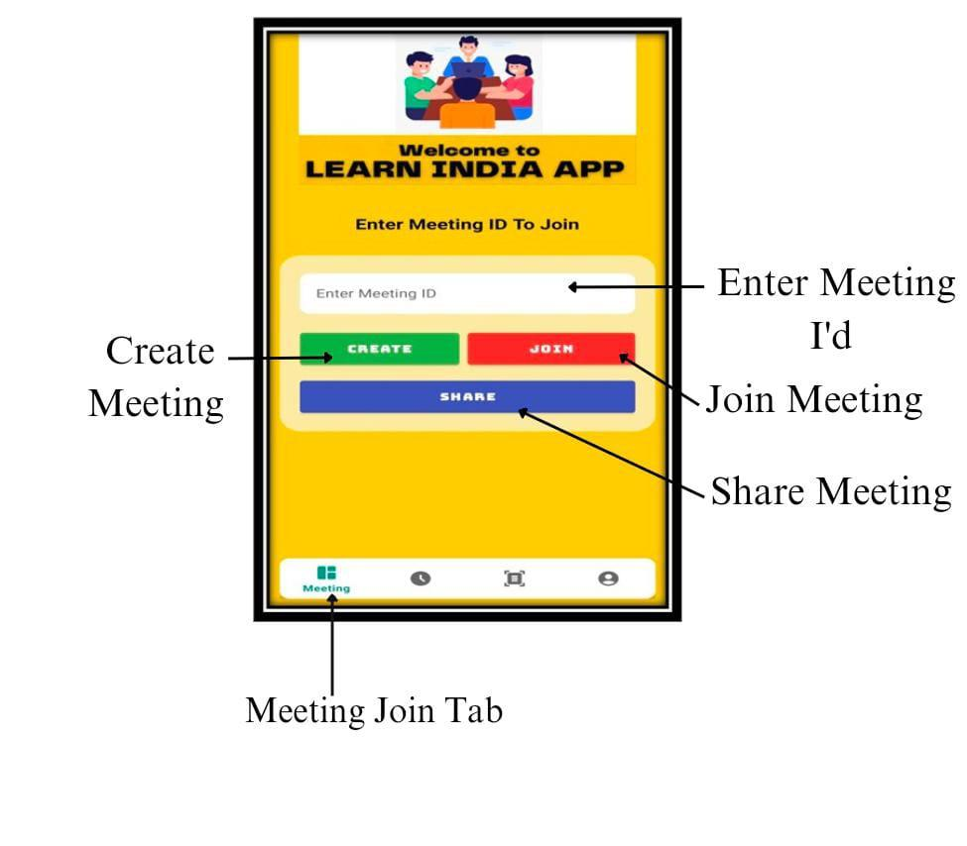

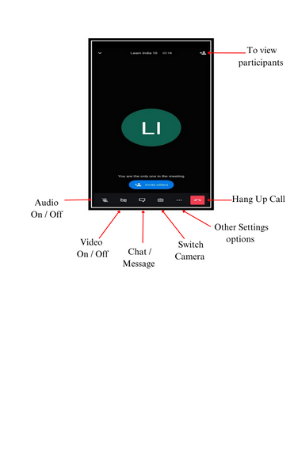

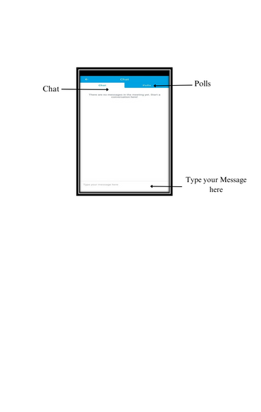

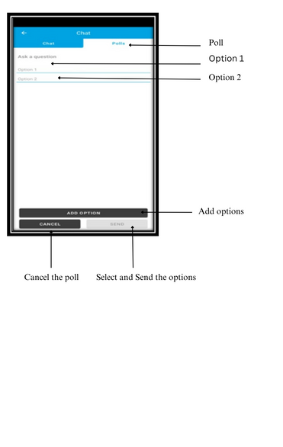

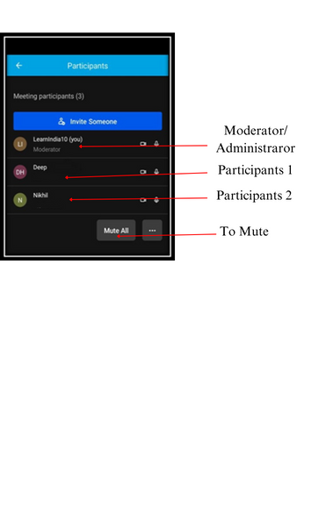

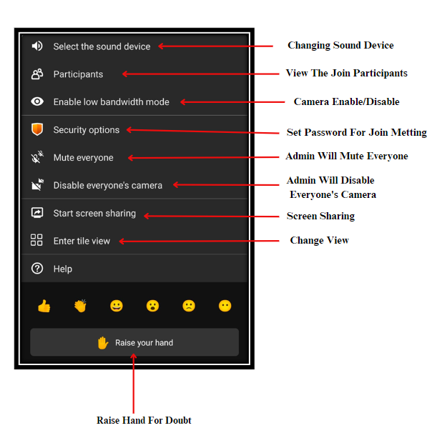

* To **View**, the **Meeting History Detail** **Click** on the **Meeting History icon.**

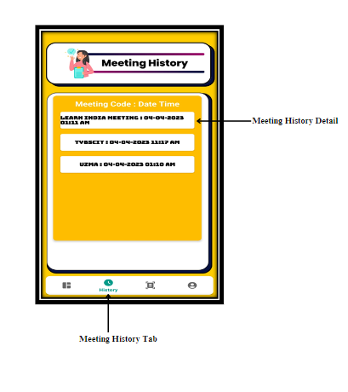

1. **PDF SHARING:**

* **Click** on the **Share icon** and **Upload the PDF** by **Clicking** on the **Upload Button.**

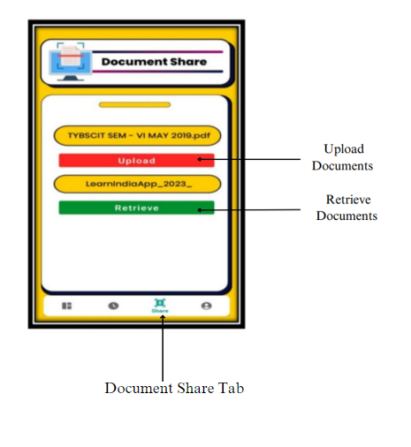

* **Click** on the **Share icon** and **Retrieve the PDF** by putting the **User’s Name** and then **Click** on the **Retrieve Button.**

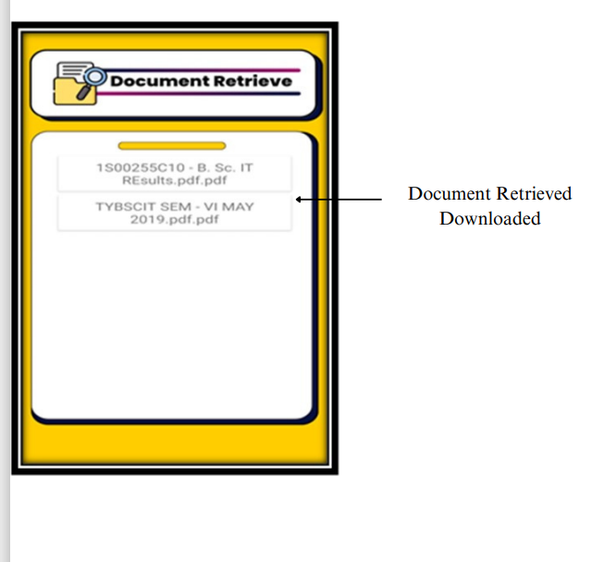

1. **USER PROFILE:**

* To **Modify** the **User** **Profile detail**, **Click** on the **User Profile icon.**

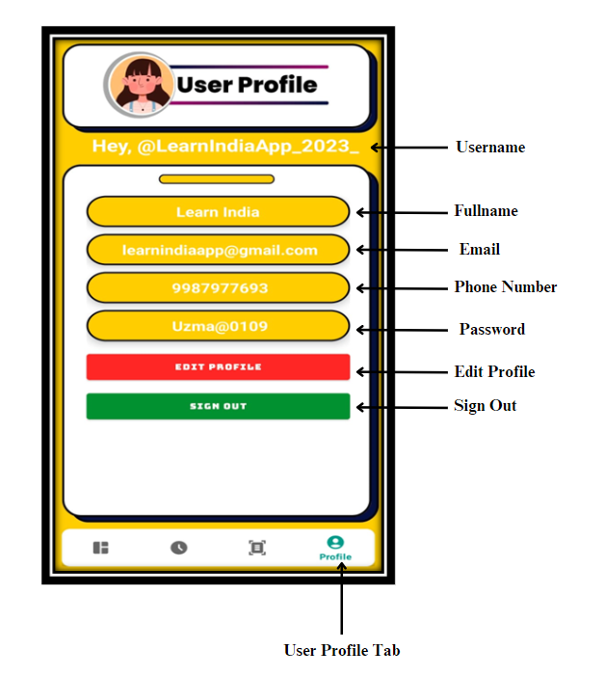

* **Click** on **Edit Button** to make the **necessary change** you want by **Clicking** on **Update Button** you will **Modify** the **User Profile.**

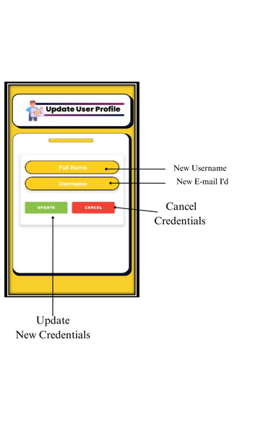

# CHAPTER 6: Conclusion And Future Work

## Conclusion:

#### The Main Objective of Video Conferencing Apps is to keep users connected and up to date

with the developing world, regardless of their location.

* + - **Video Conferencing Apps** have become valuable tools because they have **no geographical limitations.**
    - During the **Lockdown**, **Video Conferencing Apps** became a **Lifeline for Businesses, Schools, and Individuals** as they had to adapt to **remote work and learning.**
    - **Video Conferencing Apps** has become an essential tool for **communication** and collaboration in **today's digital age.**
    - As we continue to **adapt to a more digital world**, the importance of **Video Conferencing Apps**

is only going to **increase.**

* + - The **Importance of Video Conferencing Apps** has become **increasingly evident** in **recent times,** especially with the **COVID-19** pandemic forcing many people to **work and learn from home.**
    - While **Video Conferencing Apps** have become a **crucial** part of our **daily lives**, the quality and compatibility of these calls may vary depending on the device being used.
    - One of the **Primary benefits** of **Video Conferencing Apps** is their ability to bring people together from **different locations.**
    - As **technology** continues to evolve, we can expect **Video Conferencing Apps** to become even **more advanced** and **indispensable** for our daily lives.
    - **Video Conferencing Apps** are here to stay, and their **importance** will only **continue** to **grow** in the **future.**
    - These **Video Conferencing Apps** offer Features such as **Screen Sharing, Document Sharing, Meeting History Detail and Chat Functions, etc.**
    - It is important to choose a **reputable and reliable Video Conferencing App** and take necessary measures to protect your **privacy** and **security** while using it.

## Significance Of The System:

* + - **Participants** should be able to **join meetings** seamlessly **without requiring extensive technical knowledge.**
    - This ensures that **participants can join meetings** using their preferred devices or operating systems, which enhances **convenience and flexibility.**

#### The quality of audio and video is critical in Video Conferencing.

* + - **Security** is a **crucial consideration** in **Video Conferencing**, especially when discussing

#### sensitive information.

* + - A good system should have **High-Quality Audio and Video, Reliability, Security, Compatibility**, and **Ease of Use.**
    - A **User-Friendly Interface, Clear Instructions, and Minimal Technical Requirements** are some of the **Features** that make a system **Easy to use.**
    - A **System** for **Video Conferencing** refers to **the hardware and software components** used **for video communication.**
  1. **Limitations of the System:**
* **LEARN INDIA VIDEO CONFERENCING APP** can require a **stable** **internet** **connection** and good **audio** and **video** **quality**.
* **Video Conferencing App** can use a **lot** of **Bandwidth**, which can be a **problem** for people with **limited** **data** **plans** **or** **slow** **internet** **connections.**
* In **LEARN INDIA VIDEO CONFERENCING APP**the number of participants is **100 participants** can **join** a **single Meeting Room.**
* **Older devices** or **devices with outdated operating systems** may **not** support **VIDEO CONFERENCING APP**, or the **Video quality** may be **significantly lower** than **newer devices.**
* Some **Users** may have privacy concerns, feel shy or **uncomfortable** on **camera**, or **lack familiarity** with the **technology.**

## Future Scope:

* + - **Video Conferencing Technology** has come a **long way** since its **inception**, and it continues to

#### evolve rapidly.

* + - In the **future**, we can expect to see **more advanced security features** such as **Biometric Authentication** and **end-to-end Encryption.**
    - As **Video Conferencing** continue to play an increasingly **important role** in our **Daily Lives**, these advancements will **enhance communication** and **connectivity**, **creating** a more **seamless** and **immersive experience** for **Everyone**.
    - As a result, **Security and Privacy** capabilities will become **crucial**, as **companies** begin to rely on **Video Conferencing** to conduct business.
    - The **Future** of **Video Conferencing** looks **bright** with several exciting developments on the horizon, such as **Virtual Reality**, **Artificial Intelligence**, **Internet Connectivity**, and **Integration** with other **Technologies**.

# Chapter 7. References

## 7 References:

### Title of the Book, Author:

#### Professional Android 4 Application Development Book By Reto Meier.

* + **Mobile Application Development Book By Mrs. Manisha A. Pokharkar Prashant D. Somwanshi.**

### Full URL of Online References:

* + [Android Mobile App Developer Tools – Android Developers](https://developer.android.com/)
  + [Firebase Documentation (google.com)](https://firebase.google.com/docs)
  + [Connect your App to Firebase | Firebase Realtime Database (google.com)](https://firebase.google.com/docs/database/android/start)
  + [Read and Write Data on Android | Firebase Realtime Database (google.com)](https://firebase.google.com/docs/database/android/read-and-write)
  + [Stack Overflow - Where Developers Learn, Share, & Build Careers](https://stackoverflow.com/)
  + [GitHub: Let’s build from here · GitHub](https://github.com/)